|  |
| --- |
| 白板114教室 |

座位數:90

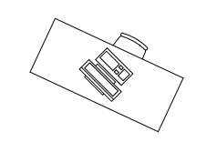

入口

|  |  |  |  |  |  |  |  |  |  |  |  |  |  |
| --- | --- | --- | --- | --- | --- | --- | --- | --- | --- | --- | --- | --- | --- |
|  |  |  |  |  |  |  |  |  |  |  |  |  |  |
|  |  |  |  |  |  |  |  |  |  |  |  |  |  |
|  |  |  |  |  |  |  |  |  |  |  |  |  |  |
|  |  |  |  |  |  |  |  |  |  |  |  |  |  |
|  |  |  |  |  |  |  |  |  |  |  |  |  |  |
|  |  |  |  |  |  |  |  |  |  |  |  |  |  |
|  |  |  |  |  |  |  |  |  |  |  |  |  |  |
|  |  |  |  |  |  |  |  |  |  |  |  |  |  |